Meets ASE Task: (A5-E-1) P-2 Check brake pedal travel with, and without, engine running to verify proper power booster operation.
Name:_____________________________________
Date:_____________
Time on Task:_____________
Make/Model/Year:____________________________________
VIN:_________________________________
Evaluation (Enter number from 4, 3, 2, 1) :_________
Vacuum Power Brake Booster Test
Page 321
1. Check the service information for the specified procedure for testing a vacuum power
brake booster for the vehicle being serviced.
__________________________________________________________________

2. With the engine off, depress the brake pedal several times until the brake pedal feels
hard (firm).

3. The brake pedal should not fall to the floor of the vehicle.

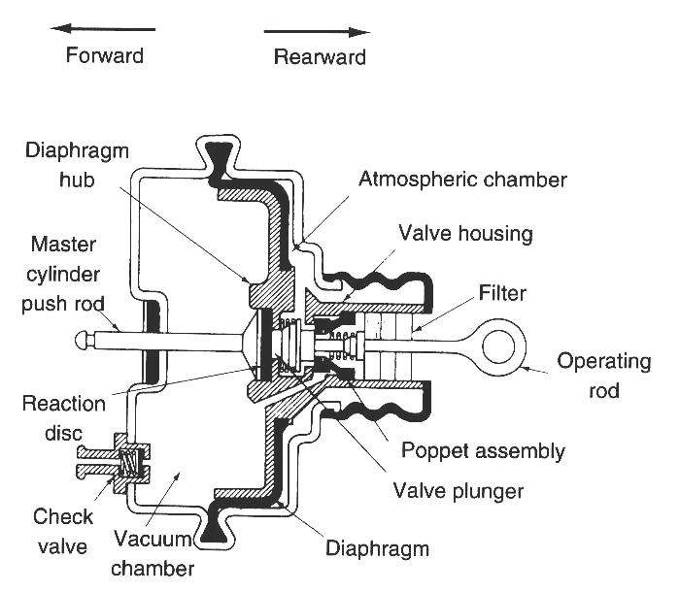
OK NOT OK

NOTE: If the brake pedal travels to the floor
of the vehicle, carefully inspect the hydraulic
brake system for a fault. Service or repair the
hydraulic brake problem before continuing
with this test.

4. With your foot still firmly depressing the brake
pedal, start the engine. The brake pedal should
go down.
OK NOT OK

5. If the brake pedal did not go down when the engine was started, visually check the
following:
Minimum of 15 in. Hg of vacuum to the vacuum booster from the engine
manifold or auxiliary vacuum pump

Proper operation of the one-way check valve

Unrestricted charcoal filter between the booster and the intake manifold (if
equipped)

Inspect for vacuum leaks
OK NOT OK

