Evaluation (Enter number from 4, 3, 2, 1) :_________
Meets ASE Task: (A0-C-4) Perform a vehicle multi-point inspection and complete a vehicle inspection report.

Safety Check

Name:_____________________________________
Date:_____________
Time on Task:_____________
Make/Model/Year:____________________________________
VIN:_________________________________
Page 32
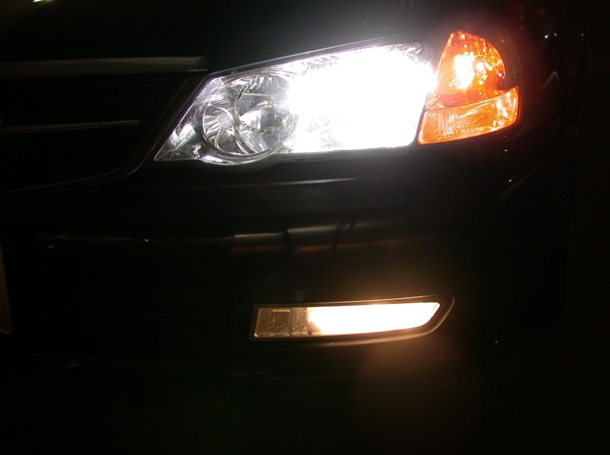
1. Check the headlights (high and low).

2. Check the taillights.
3. Check the side marker lights.

4. Check the license plate light.

5. Check the brake lights.

6. Check the turn signals.

7. Check the back-up lights with the ignition switch "on" (engine "off") and the gear
selector in reverse.

8. Check the windshield wipers (all speeds) and wiper blades.

9. Check the heater-defroster fan (all speeds).

10. Check the condition of the tires (must have at least 2/32" of tread) and the tire
pressure. Do not forget to check the spare tire!

11. Check for looseness in the steering wheel (less than 2" of play).

12. Check the 4-way emergency flashers.

13. Check the horn.

14. Listen for exhaust system leaks.

15. Check the parking brake (maximum 8-10 "clicks" and should "hold" in drive).

