Meets ASE Task: (A5-C-1) P-2 Remove, clean, and inspect brake drum; measure brake drum diameter; determine serviceability. (A5-C-2) P-2 Refinish brake drum and measure final drum diameter; compare with specifications.

Name:_____________________________________
Date:_____________
Time on Task:_____________
Make/Model/Year:____________________________________
VIN:_________________________________
Evaluation (Enter number from 4, 3, 2, 1) :_________
Brake Drum Service
Page 319
1. Check service information for the exact specifications and procedures to follow when
inspecting, measuring, and machining brake drums. Describe specified procedures.
_________________________________________________________________
_________________________________________________________________

2. Measure the drum and compare to factory specifications:
Factory specification = ______________________
Measured drum inside diameter = _____________________
OK NOT OK
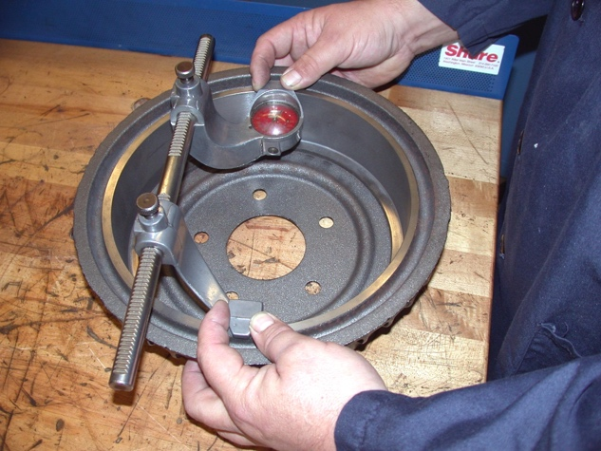

3. Machine the brake drum. Instructor’s check ____________

4. What is the measurement of the drum after machining? _____________________

