Meets ASE Task: (A5-F-3) P-2 Check parking brake operation (including electric parking brakes); check parking brake indicator light system operation; determine needed action.

Name:_____________________________________
Date:_____________
Time on Task:_____________
Make/Model/Year:____________________________________
VIN:_________________________________
Evaluation (Enter number from 4, 3, 2, 1) :_________
Parking Brake Operation
Page 318
1. Check service information for the specified procedure to follow when checking the
parking brake for proper operation.

__________________________________________________________________

__________________________________________________________________

__________________________________________________________________

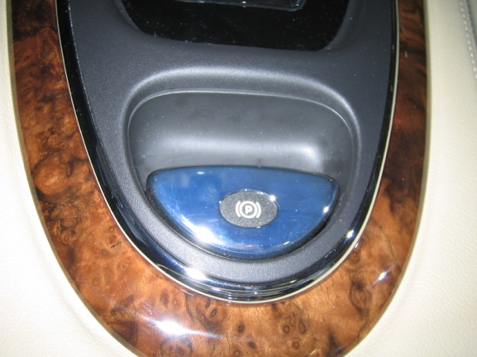
2. Identify the type of parking brake.

Foot operated

Hand operated

Push button (electric)

3. Most vehicle manufacturers specify that the parking brake be applied and that the
number of “clicks” required should be from 3 to 10. Apply the parking brake.

OK (within the specified number of clicks)

NOT OK (describe) __________________________________________

__________________________________________________________

4. Based on the check of the parking brake, what is the needed action?

________________________________________________________________

________________________________________________________________

