Meets ASE Task: (A5-F-2) P-2 Check parking brake system and components for wear, binding, and corrosion; clean, lubricate, adjust and/or replace as needed.

Name:_____________________________________
Date:_____________
Time on Task:_____________
Make/Model/Year:____________________________________
VIN:_________________________________
Evaluation (Enter number from 4, 3, 2, 1) :_________
Parking Brake Adjustment
Page 317
1. Check the service information for the specified parking brake adjustment for the
vehicle being serviced. ________________________________________________
2. Apply the parking brake and count the number of “clicks.”
less than 4 “clicks”
5 - 10 “clicks”
over 10 “clicks”
NOTE: If there are less than 4 “clicks” or more than 10 “clicks”, adjustment of the parking brake may be needed.
3. Place the gear selector in neutral and release the parking brake.
4. Hoist the vehicle safely.
5. Try rotating the rear wheels (front wheels on some Subaru vehicles).
rotates freely
does not rotate
NOTE: If the rear wheels do not rotate, try loosening the parking brake cable.
6. If the rear wheels rotate freely and the parking brake requires more than 10 “clicks,”
remove the rear brakes for inspection.
NOTE: The parking brake should only be adjusted after checking and adjusting the rear brakes.
7. Clean and adjust the rear brakes.
8. Reassemble the rear brakes and apply the parking brake 3 - 4 “clicks.”
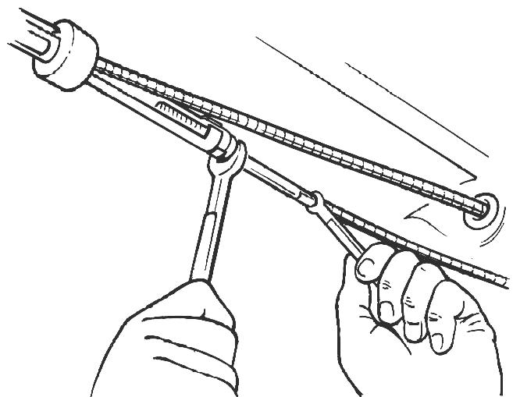
9. If the rear wheels can be rotated, adjust the parking
brake adjuster until the rear wheel brakes are just
touching the brake drums.
10. Apply the parking brake and again count the “clicks.”

