Meets ASE Task: (A5-D-9) P-1 Retract and re-adjust caliper piston on an integrated parking brake system.

Name:_____________________________________
Date:_____________
Time on Task:_____________
Make/Model/Year:____________________________________
VIN:_________________________________
Evaluation (Enter number from 4, 3, 2, 1) :_________
Rear Disc Parking Brake Adjustment
Page 316
Many vehicles equipped with rear disc brakes use a mechanical activated parking brake that is integral with the caliper. Most are designed to be self-adjusting by adjusting when excessive brake pad-to-rotor clearance occurs.

1. Check the service information for the specified rear disc brake parking brake
adjustment procedure.
_________________________________________________________________
2. Check the number of “clicks” of the parking brake.
_____ Number of clicks (should be between 3 and 9)

OK NOT OK

If over 10 clicks is needed to set the parking brake, the rear disc brake caliper needs
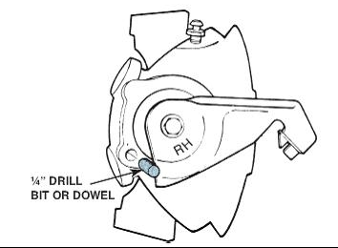
adjustment.

3. Hoist the vehicle safely and remove both rear wheels.

4. Carefully inspect the rear disc brakes for damage and
measure the pads for excessive wear.

OK NOT OK

Replace the pads if worn to the minimum
allowable thickness.

5. If the disc brake pads are serviceable, operate the parking brake lever using the
appropriate size wrench on the actuating arm retaining bolt/nut while lightly tapping
on the caliper using a dead blow plastic hammer. The adjusting mechanism should
cause the piston to be repositioned with the correct pad to rotor clearance.

OK NOT OK

If the proper clearance is not achieved, replacement of the calipers is required.

