Meets ASE Task: (A5-D-3) P-1 Remove, inspect, and/or replace brake pads and retaining hardware; determine needed action.
Name:_____________________________________
Date:_____________
Time on Task:_____________
Make/Model/Year:____________________________________
VIN:_________________________________
Evaluation (Enter number from 4, 3, 2, 1) :_________
Brake Pad Wear Indicator System

Page 314
1. Check service information for the specified procedure to follow when checking the
brake pad wear indicator system. Describe specified instructions: ________________

__________________________________________________________________

__________________________________________________________________

2. What type of brake pad wear indicator system is used on this vehicle? (check all that
apply)

Wear sensor on pads (makes noise when pads are worn)

Dash warning lamp (triggered by the sensor in the brake)

Slits cut in the disc brake pads that indicate minimum allowable thickness
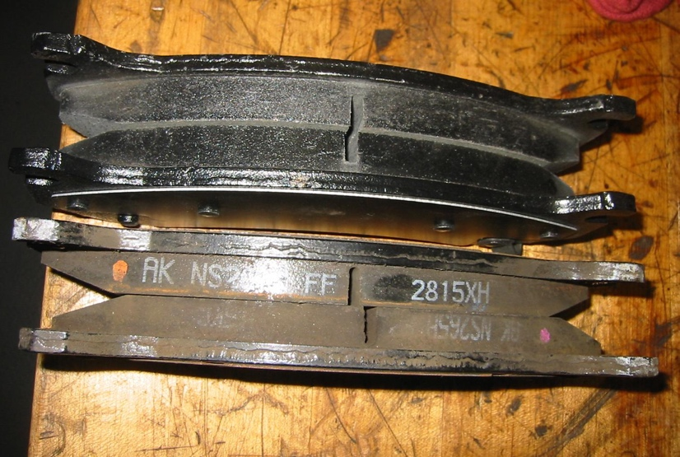

3. Based on the inspection of the brake pad wear indicator system, what is the needed
action?
_________________________________________________________________

