Meets ASE Task: : (A5-D-11) P-1 Diagnose poor stopping, noise, vibration, pulling, grabbing, dragging, or pulsation concerns; determine needed action. (A5-D-1) P-1, (A5-D-2) P-1, (A5-D-3) P-1, (A5-D-4) Disc brake caliper and related component inspection and service.

Name:_____________________________________
Date:_____________
Time on Task:_____________
Make/Model/Year:____________________________________
VIN:_________________________________
Evaluation (Enter number from 4, 3, 2, 1) :_________
Disc Brake Diagnosis and Service
Page 313
1. Check service information for the specified procedure to follow when diagnosing and
servicing disc brakes. Describe the recommended procedures.
_________________________________________________________________
_________________________________________________________________

2. Perform a thorough inspection of the disc brake system, including the condition of the
following:
A. Caliper (leaks or damage) OK NOT OK
B. Caliper mounts OK NOT OK
C. Brake pads OK NOT OK

3. Based on the inspection, what is the needed action? ___________________________
__________________________________________________________________

4. Disassemble, clean, and overhaul the disc brake calipers. Instructor’s check ______

5. Reassemble the disc brake assembly, seat the pads, bleed the brakes as needed.

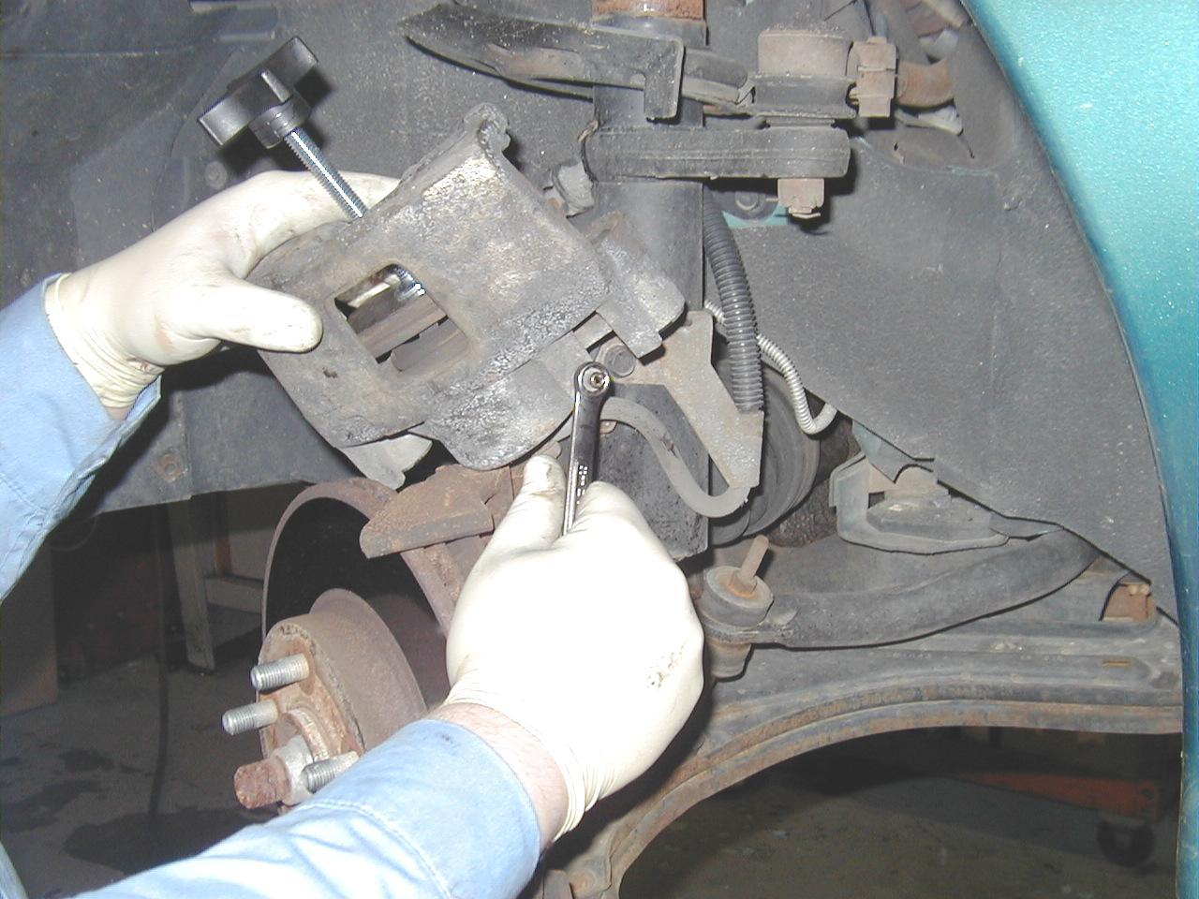
Instructor’s check ______

