Meets ASE Task: (A5-A-4) P-1 Describe procedure for performing a road test to check brake system operation, including an anti-lock brake system (ABS).

Name:_____________________________________
Date:_____________
Time on Task:_____________
Make/Model/Year:____________________________________
VIN:_________________________________
Evaluation (Enter number from 4, 3, 2, 1) :_________
Brake System Road Test
Page 312
1. Check service information for the specified procedure to follow when performing a
test drive to check for a brake system fault. Describe the specified procedure.
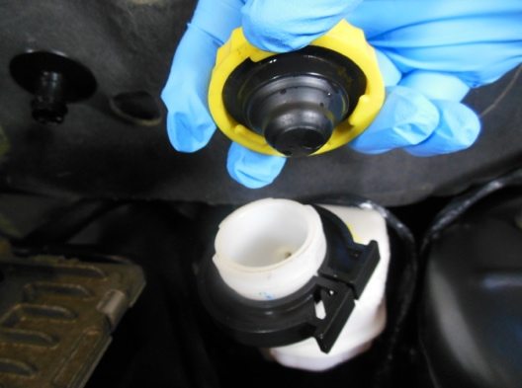
________________________
________________________
________________________
________________________
________________________

2. Check all that are specified.
Check the brake fluid level before driving
Check the brake pedal height
Perform a visual inspection of wheels/tires
Other (Specify) _________________________________________________
____________________________________________________________
CAUTION: Most experts state that the vehicle should not be road tested if the red brake
warning light is on. Always follow the vehicle manufacturer’s recommended
procedures.

