Meets ASE Task: (A5-A-2) P-1 Identify brake system components and configurations.

Name:_____________________________________
Date:_____________
Time on Task:_____________
Make/Model/Year:____________________________________
VIN:_________________________________
Evaluation (Enter number from 4, 3, 2, 1) :_________
Disc Brake Identification

Page 311
1. Check service information and/or check the vehicle to determine the following
information:

A. Type of brake system - Disc front brakes/drum rear brakes
Disc front brakes/disc rear brakes

B. Type of disc brake caliper (check all that apply) –
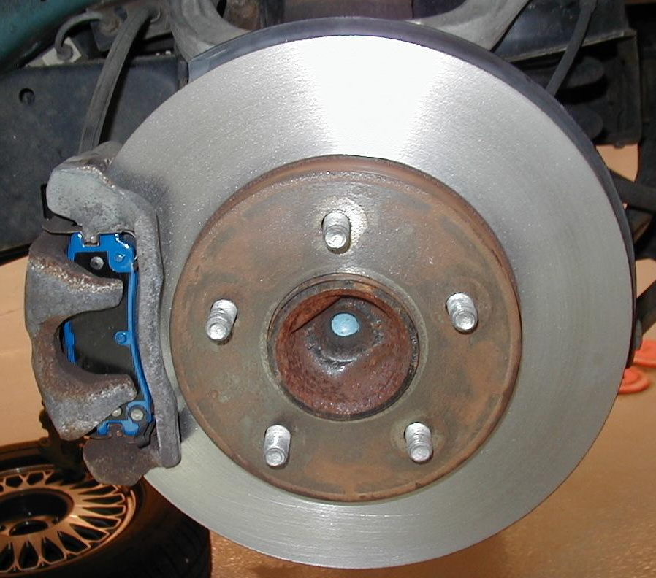
Floating
Sliding
Fixed Single piston
Two pistons
Four or six pistons

C. Type of rotors (check all that apply)

Vented front
Vented rear
Solid front
Solid rear

D. Location of caliper (forward or
rearward) –

Forward calipers =
Rearward calipers =

E. What sensor or switch is used to turn on the red brake warning light in the
event of hydraulic failure?

Brake fluid level sensor
Pressure differential switch

