Meets ASE Task: (A5-A-5) P-1 Install wheel and torque lug nuts.

Name:_____________________________________
Date:_____________
Time on Task:_____________
Make/Model/Year:____________________________________
VIN:_________________________________
Evaluation (Enter number from 4, 3, 2, 1) :_________
Install Wheel and Torque Lug Nuts
Page 310
1. Check service information and determine the vehicle manufacturer’s specified lug nut
torque specification.

___________ (usually between 80 and 100 lb-ft)

2. Use a hand-operated wire brush on the wheel studs to ensure clean and dry threads and
check for damage.

OK NOT OK Describe fault: ____________________________

3. Verify that the lug nuts are OK and free of defects.

4. Install the wheel over the studs and start all lug nuts (or bolts) by hand.

5. Tighten the lug nuts a little at a time in a star pattern using an air impact wrench
equipped with the proper torque limiting adapter or a torque wrench.

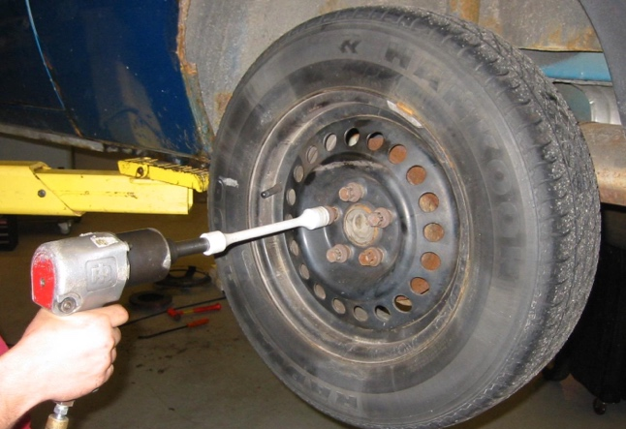
Used a torque wrench

Used an air impact with a torque
limiting adapter (torque stick)

6. Tighten the lug nuts to final torque in a star pattern.

NOTE: “Tighten one, skip one, tighten one” is the usual method if four or five
lug nuts are used.

