Name:_____________________________________
Date:_____________
Time on Task:_____________
Make/Model/Year:____________________________________
VIN:_________________________________
Evaluation (Enter number from 4, 3, 2, 1) :_________
Meets ASE Task: (A5-C-3) P-2 Remove, clean, inspect, and/or replace brake shoes, springs, pins, clips, levers, adjusters/self-adjusters, other related brake hardware, and backing support plates; lubricate and reassemble. (A5-C-4) P-2 Inspect wheel cylinders for leaks and proper operation; remove and replace as needed. (A5-C-5) P-2 Pre-adjust brake shoes and parking brake; install brake drums or drum/hub assemblies and wheel bearings; perform final checks and adjustments.

Drum Brake Service

Page 309

_____ 1. Check service information for the exact procedures to follow when inspecting and
replacing drum brake shoes and related hardware. Describe the recommended
procedures.
_________________________________________________________________
_________________________________________________________________
_____ 2. Remove, clean, and inspect the brake shoes and springs. Lubricate the backing plate.
Instructor’s check _______
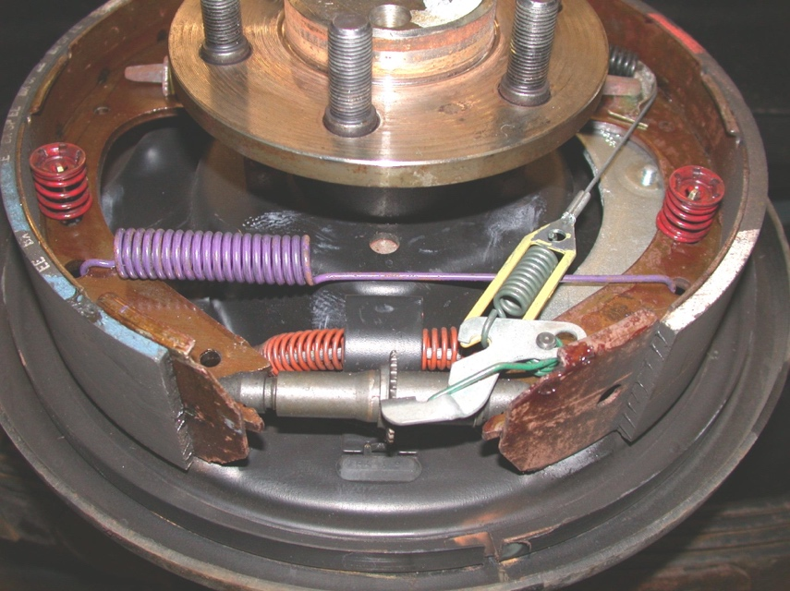

_____ 3. Inspect and install the wheel cylinders. Instructor’s check _______
_____ 4. Assemble the drum brake assemblies and adjust the parking brake and the brake
drums. Instructor’s check _______

