Meets ASE Task: (A5-C-6) P-2 Diagnose poor stopping, noise, vibration, pulling, grabbing, dragging or pedal pulsation concerns; determine needed action.

Name:_____________________________________
Date:_____________
Time on Task:_____________
Make/Model/Year:____________________________________
VIN:_________________________________
Evaluation (Enter number from 4, 3, 2, 1) :_________
Drum Brake Problem Diagnosis
Page 308
1. Verify drum brake problem concerns.
Noise (describe) ____________________________________________
Poor stopping
Pulling (toward which side?) ________________________
Grabbing (when?) ___________________________________________
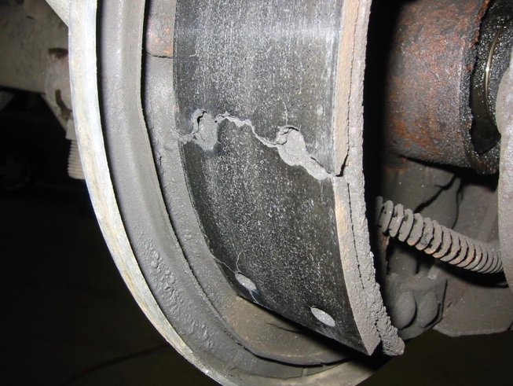
Dragging
Brake pedal pulsation

2. Hoist the vehicle safely.

3. Wet the brake drum or install a vacuum
enclosure to provide protection against
possible asbestos dust.

4. Remove the brake drums.

5. Describe the condition of the drum brake parts:

Brake drum _________________________________________________
Lining _____________________________________________________
Springs ____________________________________________________
Self-adjuster ________________________________________________
Backing plate _______________________________________________

6. Based on the diagnosis, what is the needed action?

_________________________________________________________________

_________________________________________________________________

