Meets ASE Task: (A5-A-2) P-1 Identify brake system components and configurations.

Name:_____________________________________
Date:_____________
Time on Task:_____________
Make/Model/Year:____________________________________
VIN:_________________________________
Evaluation (Enter number from 4, 3, 2, 1) :_________
Drum Brake Identification

Page 307
1. Check service information and determine the following information regarding the
drum brake design and features for the vehicle (check all that apply):

Dual servo
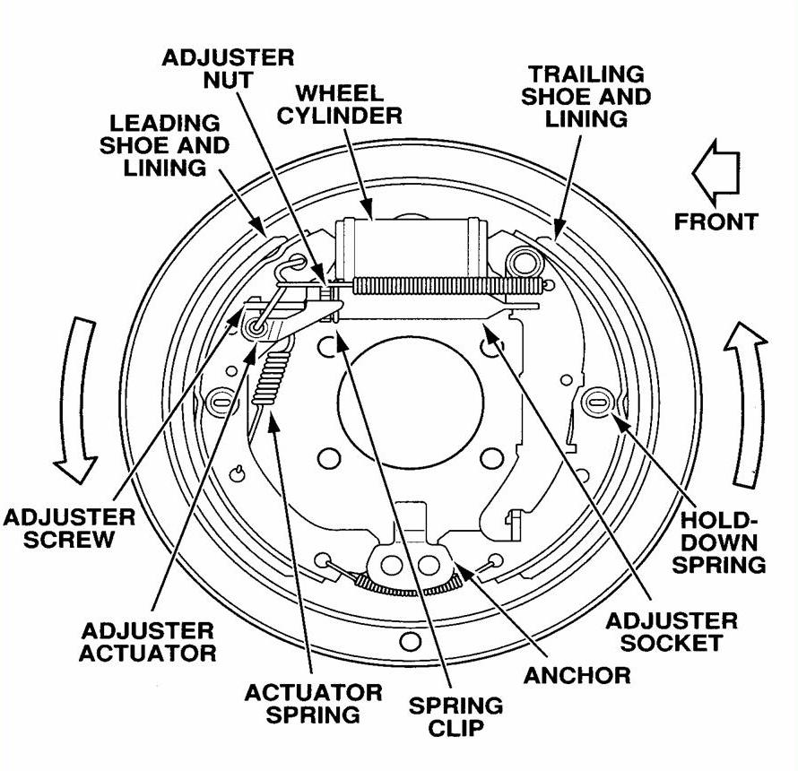
Leading trailing
Clip-on wheel cylinder
Bolted on wheel cylinder
Cast iron brake drum
Aluminum brake drum
Single U-spring design
Clip-type holddown
Coil-spring holddown
Cable-operated self-adjuster
Other (describe) _________
_____________________
_____________________

2. What is the brake drum diameter?

___________________________

3. What is the minimum allowable lining thickness?

________________________________

4. What is the maximum allowable brake drum diameter?

_________________________________

