Meets ASE Task: (A5-F-7) P-1, (A3-D-3) P-1 Remove and install sealed wheel bearing assembly.

Name:_____________________________________
Date:_____________
Time on Task:_____________
Make/Model/Year:____________________________________
VIN:_________________________________
Evaluation (Enter number from 4, 3, 2, 1) :_________
Sealed Wheel Bearing Replacement
Page 306
1. Check service information for the specified replacement procedure for the vehicle
being serviced. _______________________________________________________
________________________________________________________________

2. Loosen (do not remove) the drive axle shaft nut.

3. Hoist the vehicle safely to a good working height (about chest high).

4. Remove the front wheel.

5. Use a steel drift between the caliper and the rotor cooling vent hole to hold the rotor
from rotating.

6. Remove the drive axle shaft hub nut.

7. Remove the front disc brake caliper.

8. Remove the rotor, the hub, and splash shield retaining bolts.

9. Mark the location of the hub and make certain the hub is loose on the steering knuckle.
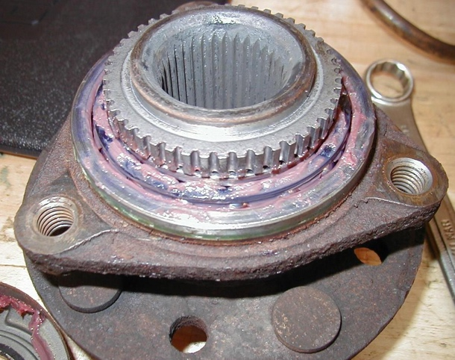
10. Install the hub puller and remove the
bearing and hub assembly.

11. Clean and lubricate hub bearing surface.

12. Reinstall the hub and bearing using the
drive axle shaft nut. (Do not torque to the
final setting, just until the hub is seated.)

13. Reinstall the rotor, caliper, and wheel.

14. Lower the vehicle and tighten the drive axle shaft nut to the final specification.
Specification = _______________ (usually about 200 lb.-ft.)

