Meets ASE Task: (A5-F-5) P-2 Inspect and replace wheel studs.

Name:_____________________________________
Date:_____________
Time on Task:_____________
Make/Model/Year:____________________________________
VIN:_________________________________
Evaluation (Enter number from 4, 3, 2, 1) :_________
Inspect and Replace Wheel Studs
Page 305
1. Hoist the vehicle safely.
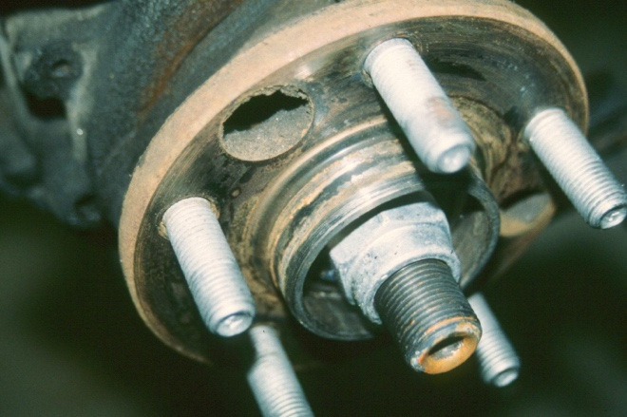
2. Remove all four wheels.

3. Carefully inspect the wheel studs for
excessive rust or damage.

LF = OK NOT OK Describe fault ______________________

RF = OK NOT OK Describe fault ______________________

LR = OK NOT OK Describe fault ______________________

RR = OK NOT OK Describe fault ______________________

4. Clean the threads using a stiff wire brush.

CAUTION: Many vehicle manufacturers specify that grease or oil should not be used on the threads of wheel studs. If a lubricant is used on the threads, the lug nuts could loosen during vehicle operation, which could cause a wheel to fall off resulting in a collision and possible personal injury.

5. Worn or damaged studs should be replaced. Check the service information for the
specified procedure for replacing wheel studs on the vehicle being serviced.

__________________________________________________________________

6. Which stud(s) were replaced? _____________________________________

