Meets ASE Task: (A4-D-2) P-2 Inspect, service, and/or replace front and rear wheel bearings. (A5-F-1) P-2 Remove, clean, inspect, repack, and install wheel bearings; replace seals; install hub and adjust bearings.

Name:_____________________________________
Date:_____________
Time on Task:_____________
Make/Model/Year:____________________________________
VIN:_________________________________
Evaluation (Enter number from 4, 3, 2, 1) :_________
Wheel Bearing and Race Replacement

Page 304
1. Remove the wheel cover and the hub
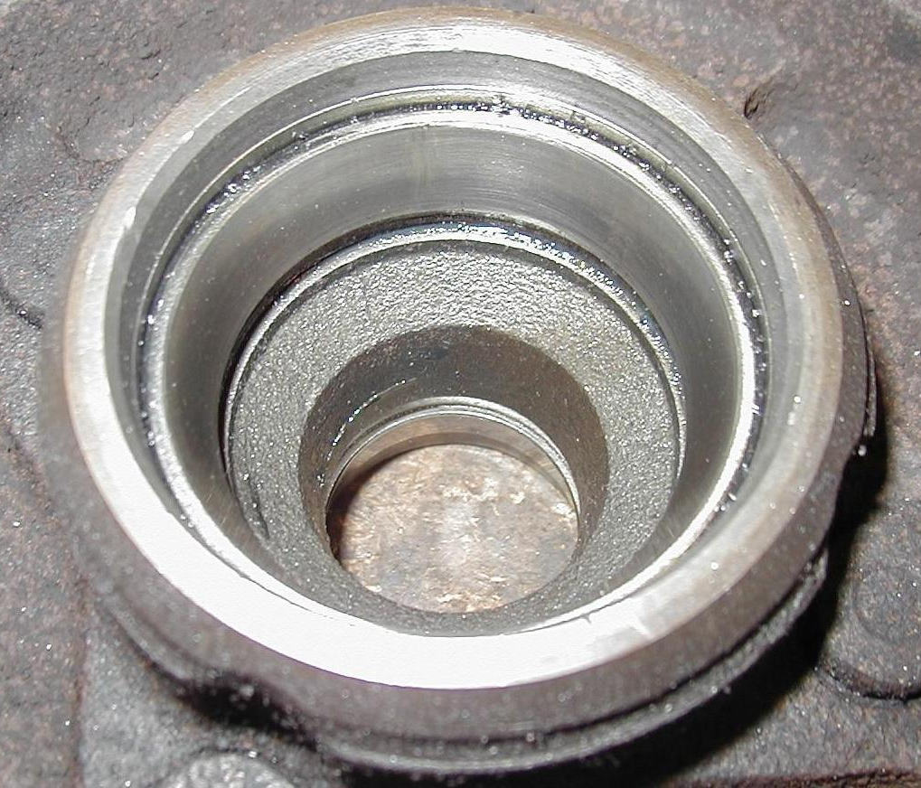
dust cap (grease cap).

2. Remove and discard the cotter key.

3. Remove the spindle nut, washer, and outer bearing.

4. Remove inner and outer bearing and grease seal.

5. Remove the bearing race using the specified tool.

6. Show the instructor the removed race.
Instructor's OK _______________

7. Install new race using the correct bearing race installation tool.

8. Show the instructor the new race. Instructor's OK _______________

9. Install a new grease seal using a seal installing tool.

10. Pack the new bearing with the correct type of wheel bearing grease.

11. Correctly adjust the bearing preload:
Install the spindle nut and while rotating the tire assembly, tighten (snug
only, 12 to 30 lb.-ft.) with a wrench to "seat" the bearing correctly in the
race.
While still rotating the tire assembly, loosen the nut approximately 1/2 turn
and then hand tighten only.
Install a new cotter key (the common size is 1/8” diameter and 1.5 inches
long).
Bend the ends of the cotter key up and around the nut to prevent
interference with the dust cap.

12. Install the hub dust cap (grease cap) and wheel cover.

