Meets ASE Task: (A4-D-2) P-2 Inspect, service, and/or replace front and rear wheel bearings. (A5-F-1) P-2 Remove, clean, inspect, repack, and install wheel bearings; replace seals; install hub and adjust bearings.

Name:_____________________________________
Date:_____________
Time on Task:_____________
Make/Model/Year:____________________________________
VIN:_________________________________
Evaluation (Enter number from 4, 3, 2, 1) :_________
Wheel Bearing Service

Page 303
1. Remove the wheel cover and the hub dust cap (grease cap).
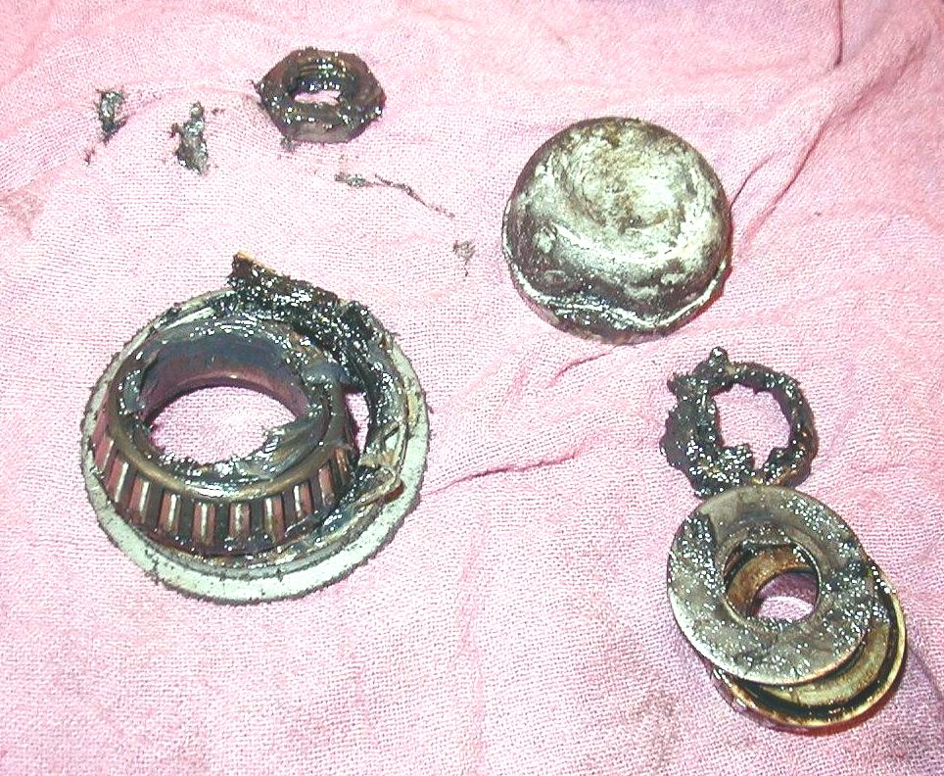
2. Remove and discard the cotter key.

3. Remove the spindle nut, washer and outer
bearing.

4. Remove inner and outer bearing and grease
seal.

5. Thoroughly clean the bearing in solvent and
denatured alcohol or brake cleaner and blow it dry with compressed air.

6. Closely inspect the bearing for wear or
damage.

7. Show the instructor the cleaned bearing. Instructor's OK _______________

8. Repack the bearing with the correct type of wheel bearing grease.

9. Install a new grease seal using a seal installing tool.

10. Correctly adjust the bearing preload:
Install the spindle nut and while rotating the tire assembly, tighten (snug
only, 12 to 30 lb.-ft.) with a wrench to "seat" the bearing correctly in the
race.
While still rotating the tire assembly, loosen the nut approximately 1/2 turn
and then hand tighten only.
Install a new cotter key (the common size is 1/8” diameter and 1.5 inches
long).
Bend the ends of the cotter key up and around the nut to prevent
interference with the dust cap.

11. Install the hub dust cap (grease cap) and wheel cover.

