Meets ASE Task: (A4-D-2) P-2 Inspect, service, and/or replace front and rear wheel bearings. (A5-F-1) P-2 Remove, clean, inspect, repack, and install wheel bearings; replace seals; install hub and adjust bearings.

Name:_____________________________________
Date:_____________
Time on Task:_____________
Make/Model/Year:____________________________________
VIN:_________________________________
Evaluation (Enter number from 4, 3, 2, 1) :_________
Wheel Bearing Diagnosis
Page 302
Worn or defective wheel bearings can cause a variety of concerns including:

Noise – usually a growl or rumble that changes tone with vehicle speed.
Wheel Shimmy – Can occur if the bearings are loose or excessively worn.
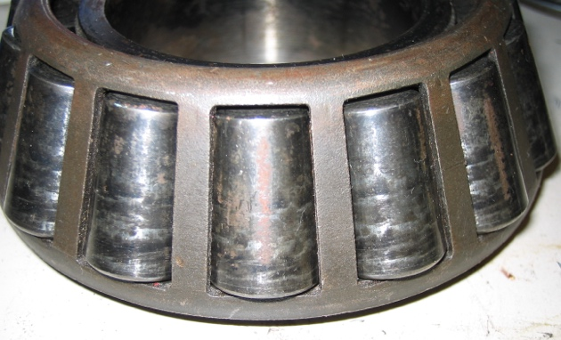
Vibration – Can occur if the bearings are loose or excessively worn.

1. Check service information for the
recommended test procedures to follow to
diagnose possible wheel bearing noise.
______________________________
______________________________

2. Drive the vehicle and check for abnormal noise that could be caused by a defective
wheel bearing.

OK NOT OK

HINT: A defective wheel bearing often sounds like a noisy winter tire but does not change tone when the vehicle is being driven over various road surfaces.

3. Hoist the vehicle safely and check for excessive wheel bearing play and/or noise.

OK NOT OK

Describe the faults and location: _______________________________________

4. Based on the diagnosis, what is the needed action? ___________________________
_________________________________________________________________
________________________________________________________________

