Meets ASE Task: (A5-B-7) P-1 Bleed and/or flush the brake system.

Name:_____________________________________
Date:_____________
Time on Task:_____________
Make/Model/Year:____________________________________
VIN:_________________________________
Evaluation (Enter number from 4, 3, 2, 1) :_________
Brake Bleeding

Page 301
1. Check service information for the specified procedure to follow when bleeding and/or
flushing the brake system. Describe the specified procedure.
_________________________________________________________________
_________________________________________________________________
2. Perform a brake bleeding/flushing procedure. Instructor’s check _____________
3. Which method(s) was used (check all that apply)?
Normal (single stroke) method
Pressure bleeding
Vacuum bleeding
Gravity bleeding
Brake system was flushed
4. Was the use of a scan tool needed or suggested?
Yes (What scan tool?) ________________________________________
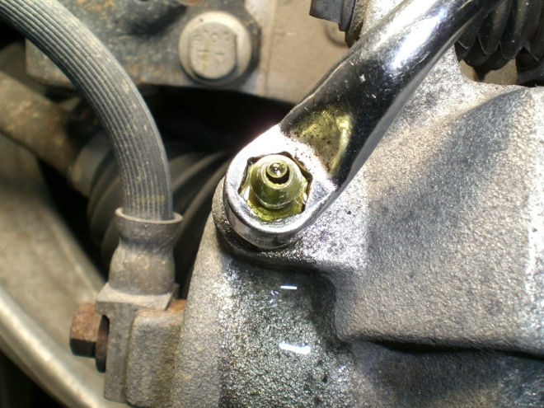
No

