Meets ASE Task: (A5-B-5) P-1 Select, handle, store, and fill brake fluids to proper level; use proper fluid type per manufacturer specification. (A5-B-13) P-1 Test brake fluid for contamination.

Name:_____________________________________
Date:_____________
Time on Task:_____________
Make/Model/Year:____________________________________
VIN:_________________________________
Evaluation (Enter number from 4, 3, 2, 1) :_________
Brake Fluid

Page 300
1. Check service information for the specified brake fluid and when to check for the
proper level.
A. Specified brake fluid = ____________________________________________
B. Specified brake fluid level _________ (describe the location) _____________

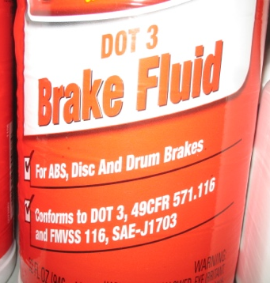

2. Check service information for the recommended procedure to follow to determine if
the brake fluid is contaminated. Describe the specified procedure:
__________________________________________________________________
__________________________________________________________________
3. Check all that apply according to service information.
Perform a visual inspection.
Place the sample in Styrofoam cup and check for eating away of the cup at
the top of the fluid level line.
Use a test strip.
Use a brake fluid boiling temperature tester
Other (describe) ___________________________________________

