Evaluation (Enter number from 4, 3, 2, 1) :_________
Meets ASE Task: (A8-E-1) P-1 Identify emission control system components and configurations.

Vehicle Emission Control Information

Name:_____________________________________
Date:_____________
Time on Task:_____________
Make/Model/Year:____________________________________
VIN:_________________________________
Page 30
1. Locate the vehicle emission control information (VECI) sticker and describe its
location: _____________________________________________________________
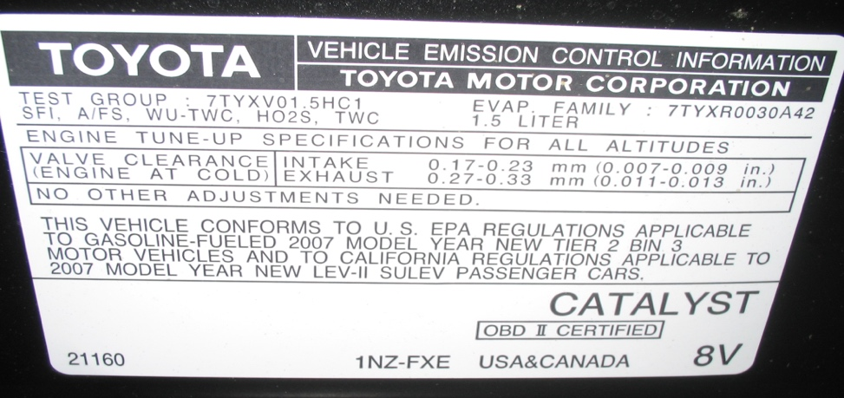

2. List what service information is included on the sticker: _______________________
_________________________________________________________________
_________________________________________________________________
3. List emission control devices on the vehicle: _________________________________
__________________________________________________________________
__________________________________________________________________
4. What is the U.S. Federal emission rating of the vehicle? _______________________
5. What is the California emission rating of the vehicle? __________________________

