Meets ASE Task: (A5-B-4) P-1 Inspect brake lines, flexible hoses, and fittings for leaks, dents, kinks, rust, cracks, bulging, wear; and loose fittings /supports; determine needed action. (A5-B-12) P-2 Fabricate brake lines using proper material and flaring procedures.

Name:_____________________________________
Date:_____________
Time on Task:_____________
Make/Model/Year:____________________________________
VIN:_________________________________
Evaluation (Enter number from 4, 3, 2, 1) :_________
Brake Hoses and Lines
Page 299
1. Check service information for the specified procedure to follow when inspecting
and/or replacing brake hoses and lines. Describe the recommended procedures.
__________________________________________________________________
__________________________________________________________________
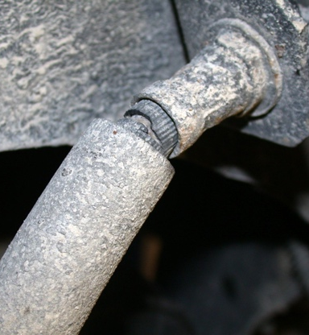
2. Based on the inspection of the brake lines and hoses,
what is the needed action?
________________________________________
________________________________________
________________________________________
________________________________________

3. Using the specified diameter of brake line, perform two brake line flaring procedures.

Double flare Instructor’s check ___________
ISO (bubble) flare Instructor’s check ___________
4. Bend brake line as needed. Instructor’s check ___________
