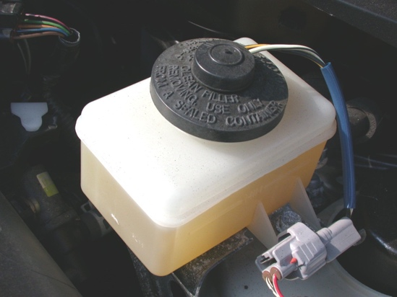
Meets ASE Task: (A5-B-6) P-1 Identify components of hydraulic brake warning light system. (A5-B-13) P-3 Inspect, test and/or replace components of brake warning light system.

Name:_____________________________________
Date:_____________
Time on Task:_____________
Make/Model/Year:____________________________________
VIN:_________________________________
Evaluation (Enter number from 4, 3, 2, 1) :_________
Red Brake Warning Lamp Diagnosis
Page 297
1. Does the vehicle use a brake fluid level sensor?
Yes No
(If yes, describe the location: __________________________________.)
2. Does the vehicle use a pressure differential
switch?
Yes No
(If yes, describe the location: _________________________________________.)
3. With the ignition key on, engine off (KOEO), apply the parking brake. Did the red
brake warning lamp light?
Yes No
(If no, why not? ____________________________________________________)
4. Unplug the wiring connector from the brake fluid level sensor or pressure differential
switch. With the key on, engine off (KOEO), did the red brake warning lamp light?
Yes No (It should not have come on.)
5. State the vehicle manufacturer’s recommended inspection, testing, and replacement
procedures:

__________________________________________________________________
__________________________________________________________________
__________________________________________________________________
__________________________________________________________________

