**Meets ASE Task:** (A5-B-3) P-1 Check master cylinder for internal/external leaks and proper operation; determine needed action.

Name:_____________________________________

Date:_____________

Time on Task:_____________

Make/Model/Year:____________________________________

VIN:_________________________________

Evaluation (Enter number from 4, 3, 2, 1) :_________

**Hydraulic System Fault Analysis**

Page 295

Poor stopping or dragging brakes or pulling can be caused by hydraulic system failure or faults.

**1**. Check master cylinder for proper brake fluid level and condition.

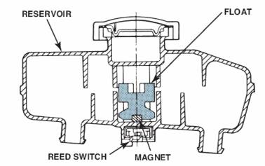

**2.** Verify proper operation of the base brakes.

OK

Pulls to the left during braking (see Step 3).

Pulls to the right during braking (see Step 3).

Brakes do not release fully (see Step 4).

Poor stopping (see Step 5).

Other brake system concerns (describe) ____________________________

**3.** Pulling can be caused by a stuck caliper piston on the side *opposite* the direction of the

pull.

If there is a pull to the right during braking, check the left side caliper.

**OK**  **NOT OK**

If there is a pull to the left during braking, check the right side caliper.

**OK**  **NOT OK**

**4.** Brakes that do not fully release can be caused by a fault with the flexible brake hose

and/or a stuck caliper piston

Visually check the flexible brake hose. **OK**  **NOT OK**

Check that the caliper piston can be moved into the caliper bore easily.

**OK**  **NOT OK**

5. Poor stopping can be caused by a stuck caliper or wheel cylinder piston. Check that

all hydraulic pistons are free.

**LF = OK**  **NOT OK**

**RF = OK**  **NOT OK**

**LR = OK**  **NOT OK**

**RR= OK**  **NOT OK**