**Meets ASE Task:** (A5-B-2) P-1 Describe and measure brake pedal height, travel, and free play (as applicable); determine needed action.

Name:_____________________________________

Date:_____________

Time on Task:_____________

Make/Model/Year:____________________________________

VIN:_________________________________

Evaluation (Enter number from 4, 3, 2, 1) :_________

**Brake Pedal Height**

Page 293

**1.** State the vehicle manufacturer’s specified brake height testing procedure:

__________________________________________________________________

__________________________________________________________________

__________________________________________________________________

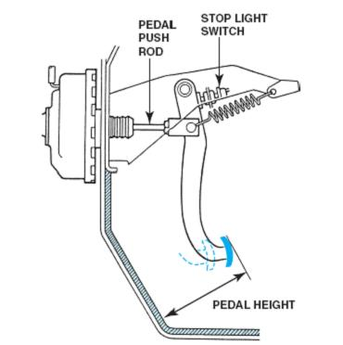**­­­­** **2.** Measure the brake pedal height from the bottom

of the steering wheel or floor to the brake pedal.

________ = inch (cm)

**3.** Depress the brake pedal until the brakes are

applied and measure the brake pedal height.

________ = inch (cm)

**4.** Subtract the second reading from the first

reading. This is the brake pedal travel.

_______ = brake pedal travel (should be a maximum of 2.0 to 2.5 in.)

**5.** List three items that could cause a greater than normal brake pedal travel.

A. _______________________________

B. _______________________________

C. _______________________________

**6.** Based on the test results, what is the needed action: ___________________________

_________________________________________________________________