Meets ASE Task: (A5-B-1) P-1 Demonstrate understanding of hydraulic principals; diagnose pressure concerns in the brake system using hydraulic principles (Pascal’s Law).

Name:_____________________________________
Date:_____________
Time on Task:_____________
Make/Model/Year:____________________________________
VIN:_________________________________
Evaluation (Enter number from 4, 3, 2, 1) :_________
Hydraulic Pressure Analysis
Page 292
1. Remove the disc brake calipers and install a force gauge between the caliper piston
and the caliper housing.

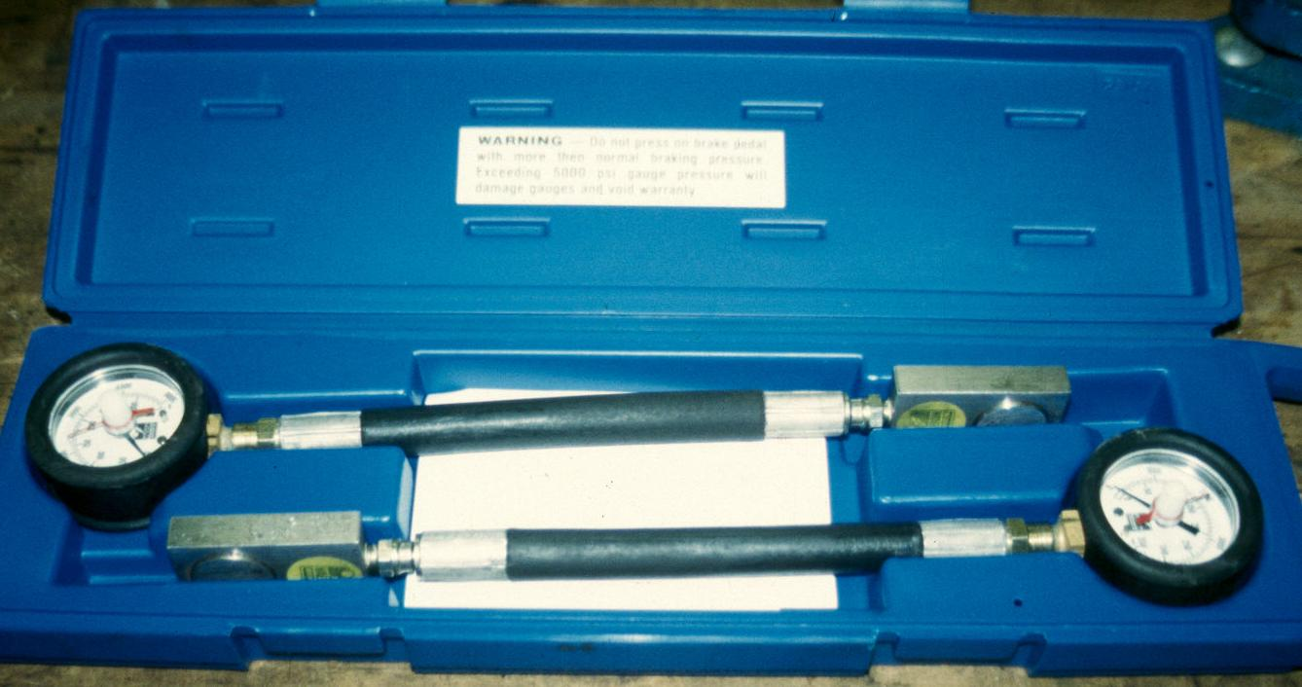

2. Depress the brake pedal and observe the force readings.

Left side = ______ pounds Right side = ______ pounds

The readings should be the same. OK NOT OK

3. List possible causes that could prevent the force reading to be different from one side
to the other.

A. ___________________________________________________
B. ___________________________________________________
C. ___________________________________________________

4. Based on the test results, what is the needed action?
_________________________________________________________________
_________________________________________________________________

