Meets ASE Task: (A0-F-11) Uses scientific, technical, engineering and mathematics (STEM) principles and reasoning to accomplish assigned tasks.

Name:_____________________________________
Date:_____________
Time on Task:_____________
Make/Model/Year:____________________________________
VIN:_________________________________
Evaluation (Enter number from 4, 3, 2, 1) :_________
Brake System Principles
Page 290
The energy required to slow and/or stop a vehicle depends on two major factors:
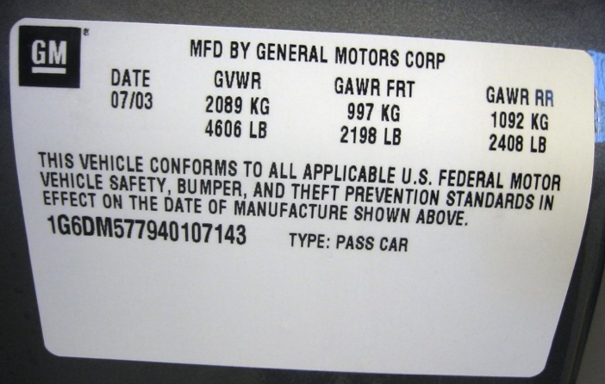
- Weight of the vehicle
- Speed of the Vehicle

1. Check service information and determine
the weight of the vehicle.

Weight = ___________

2. Add the number of possible passengers (one for each location equipped with seat belts
times 150 pounds each):

Number of passengers = ______ × 150 pounds = _____________

3. Add possible luggage or cargo (see tire pressure decal) weight:

Luggage or cargo = ________

4. Total vehicle weight = ___________

5. Using the formula, determine the kinetic energy at the following speeds:

weight × speed² = kinetic energy
29.9

30 mph = _________

60 mph = _________

