Meets ASE Task: (A5-A-2) P-1 Identify brake system components and configurations.

Name:_____________________________________
Date:_____________
Time on Task:_____________
Make/Model/Year:____________________________________
VIN:_________________________________
Evaluation (Enter number from 4, 3, 2, 1) :_________
Brake System Component Identification
Page 289
1. Front disc brake design type (check all that apply):

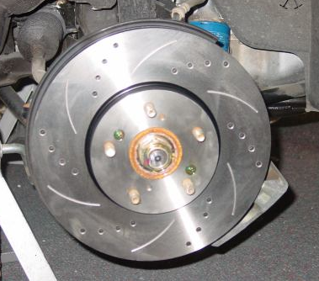
A. Single piston caliper
B. Two piston caliper
C. Four or six piston caliper
D. Fixed-type caliper design
E. Floating- or sliding-type caliper design

2. Front rotor:

A. Vented
B. Solid

3. Rear brakes (check all that apply):

A. Drum brakes
B. Disc brakes with integral parking brake
C. Disc brake with auxiliary parking drum brake
D. Other (describe) ___________________________________

4. Type of parking brake application:

Hand operated
Foot operated
Electric

5. Type of parking brakes (check which):

Drum brake
Part of rear disc brake
Separate drum brake along with rear disc brake
Other (describe) __________________________________________

