Meets ASE Task: (A8-A-2) P-1 Retrieve and record DTCs, OBD monitor status, and freeze frame data; clear codes and data when directed.
Name:_____________________________________
Date:_____________
Time on Task:_____________
Make/Model/Year:____________________________________
VIN:_________________________________
Evaluation (Enter number from 4, 3, 2, 1) :_________
Engine Diagnosis
Page 279
1. Check service information for the specified method for retrieving diagnostic trouble
codes on the OBD II vehicle being serviced.
_________________________________________________________________
_________________________________________________________________
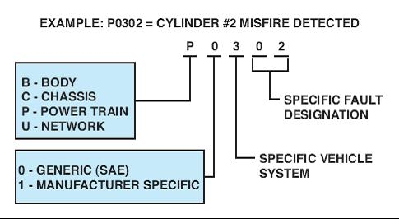
2. Set a diagnostic trouble
code by unplugging a
component that is check by
the comprehensive
component monitor (CCM),
such as the throttle position
sensor.
3. Retrieve and record the stored diagnostic trouble code (DTC).

Which code(s) was set? _______________________________________________

4. Using specified testing procedures, what system is at fault? __________________
_______________________________________________________________

5. What is the needed action? ____________________________________________
_______________________________________________________________
_______________________________________________________________

