**Meets ASE Task:** (A8-B-3) P-1 Perform active tests of actuators using a scan tool; determine needed action.

Name:_____________________________________

Date:_____________

Time on Task:_____________

Make/Model/Year:____________________________________

VIN:_________________________________

Evaluation (Enter number from 4, 3, 2, 1) :_________

**Testing Using a Scan Tool**

Page 277

**1.** Check service information for what actuator can be commanded by using a scan

tool. List the actuator that can be controlled.

**________________ ________________ ________________**

**________________ ________________ ________________**

**________________ ________________ ________________**

**________________ ________________ ________________**

**________________ ________________ ________________**

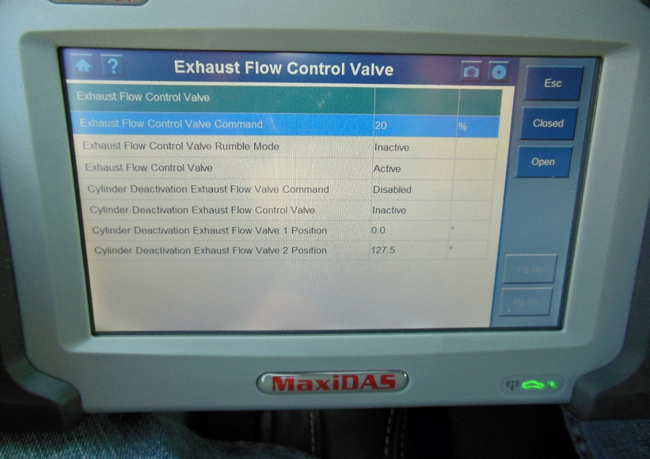

**2.** Based on the results of performing active e tests of an actuator, what is the needed

action? ___________________________________________________________

______________________________________________________________

______________________________________________________________

______________________________________________________________