Meets ASE Task: (A8-B-2) P-1 Access and use service information to perform step-by-step (troubleshooting) diagnosis.

Name:_____________________________________
Date:_____________
Time on Task:_____________
Make/Model/Year:____________________________________
VIN:_________________________________
Evaluation (Enter number from 4, 3, 2, 1) :_________
Access Service Information
Page 276
1. What is the name of the name of the service information being used. Check all that
apply.
Mitchell On Demand (ProDemand)
Alldata
Vehicle manufacturer specific service information (list). _________________
______________________________________________________________
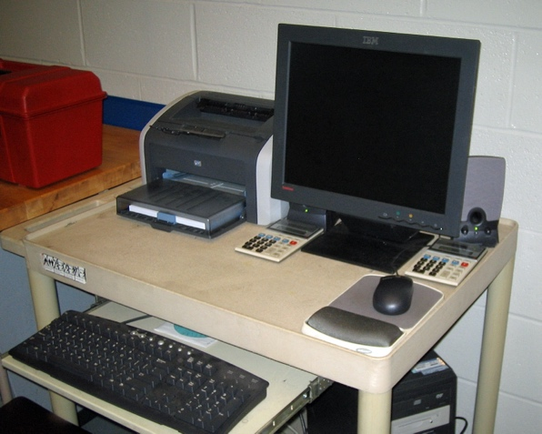
2. How is service information accessed in the
shop. Check all that apply.
Desktop computer
Laptop computer
Tablet
Phone
Other (Describe) ______________
_____________________________
3. Select a typical fault and then describe where in service information the step-by-step
diagnostic procedure is located. Describe ___________________________________



