Meets ASE Task: (A8-A-2) P-1 Retrieve and record DTCs, OBD monitor status, and freeze frame data; clear codes and data when directed.

Name:_____________________________________
Date:_____________
Time on Task:_____________
Make/Model/Year:____________________________________
VIN:_________________________________
Evaluation (Enter number from 4, 3, 2, 1) :_________
OBD II Connector Identification
Page 272
1. Check service information and check which cavities of the OBD II diagnostic link
connector (DLC) have electrical (metal) terminals.
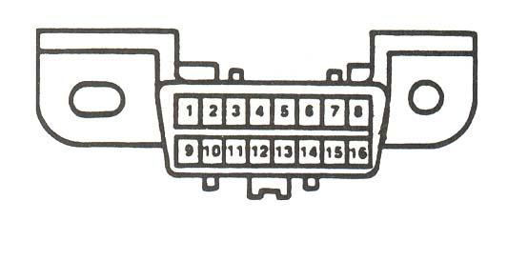

2. Use service information and determine the identification for each of the terminals.

1. ___________________________________
2. ___________________________________
3. ___________________________________
4. ___________________________________
5. ___________________________________
6. ___________________________________
7. ___________________________________
8. ___________________________________
9. ___________________________________
10. ___________________________________
11. ___________________________________
12. ___________________________________
13. ___________________________________
14. ___________________________________
15. ___________________________________
16. ___________________________________

