Meets ASE Task: (A8-E-6) P-1 Diagnose emission and drivability concerns caused by catalytic converter system; determine needed action.
Name:_____________________________________
Date:_____________
Time on Task:_____________
Make/Model/Year:____________________________________
VIN:_________________________________
Evaluation (Enter number from 4, 3, 2, 1) :_________
Catalytic Converter Test
Page 271
1. Check service information for the recommended test to perform on the catalytic
converter.

__________________________________________________________________

__________________________________________________________________
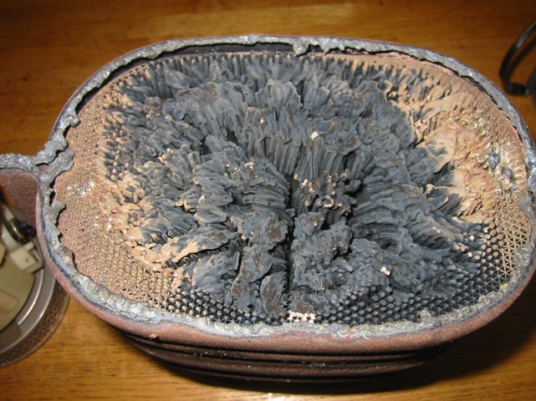
2. The recommended test(s) include the
following. Check all that apply.

Check for loose substrate (rattle
noise)

Check temperature differences

Use propane

Use an exhaust gas analyzer

Other (describe) _____________________________________________

3. Which tests were performed and what were the results?

a. _______________________ Result: ________________________________

b. _______________________ Result: ________________________________

c. _______________________ Result: ________________________________

4. Based on the tests and inspection of the catalytic converter, what is the needed
action?

__________________________________________________________________

__________________________________________________________________

