Meets ASE Task: (A8-D-12) P-2 Perform exhaust system back-pressure test; determine needed action.
Name:_____________________________________
Date:_____________
Time on Task:_____________
Make/Model/Year:____________________________________
VIN:_________________________________
Evaluation (Enter number from 4, 3, 2, 1) :_________
Exhaust System Backpressure Test
Page 270
A clogged or partially restricted exhaust greatly affects engine performance. Lack of power is a common symptom of a partially restricted exhaust system. In severe cases, the engine may start/stall due to exhaust system restriction.

1. Check service information for the specified maximum backpressure. ______________

__________________________________________________________________
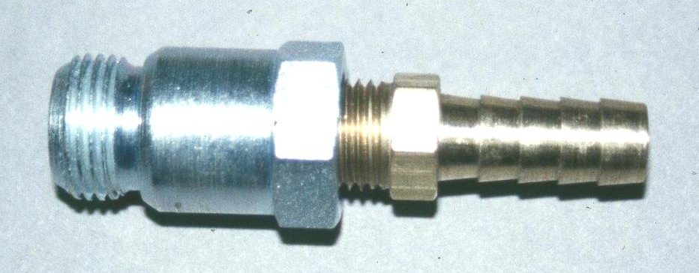
2. Remove the oxygen sensor from the
exhaust manifold and install tool to
measure exhaust back pressure.

NOTE: This tool can be made from an 18 mm fitting and a vacuum hose nipple.

3. Connect a vacuum/pressure gauge to the exhaust back pressure tool. Start the engine
and run at idle and observe exhaust back pressure.

______ psi back pressure (maximum allowable back pressure at idle
is 1.25 psi.)

OK NOT OK

4. Operate the engine at a constant speed of 2500 RPM and observe the exhaust back
pressure.

______ psi back pressure (Maximum allowable back pressure at 2500
RPM is 2.5 psi.)

OK NOT OK

5. Based on the results of the backpressure test, what is the needed action?

_________________________________________________________________

