Evaluation (Enter number from 4, 3, 2, 1) :_________
Meets ASE Task: (A1 through A8-A-1) P-1 Research vehicle service information such as fluid type, vehicle service history, service precautions, technical service bulletins, and recalls including vehicles equipped with advanced driver assistance systems (ADAS).

Service Manual Usage

Name:_____________________________________
Date:_____________
Time on Task:_____________
Make/Model/Year:____________________________________
VIN:_________________________________
Page 27
Look up the following service information and record the page number or document number where the information was found.

Spark plug number: __________________ location found _____________

Spark plug gap: ________ location found _____________

Number of quarts of oil for an oil change: ______________ location found _____________

Viscosity of engine oil recommended: ________ location found _____________
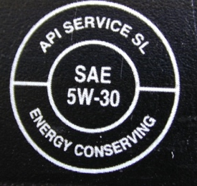

Air filter part number: _____________ location found _____________

Fuel filter part number: _____________ location found _____________

AC generator (alternator) output: ________ amps location found _____________

Bore and stroke of the engine: bore ______ stroke ______ location found _____________

Valve cover bolt torque specification: _________________ location found _____________

