**Meets ASE Task:** (A8-E-5) P-3 Inspect and test electrical/electronically operated components and circuits of secondary air injection systems; determine needed action.

Name:_____________________________________

Date:_____________

Time on Task:_____________

Make/Model/Year:____________________________________

VIN:_________________________________

Evaluation (Enter number from 4, 3, 2, 1) :_________

**AIR Pump Electrical Component Inspection**

Page 269

**1.** Check service information for the recommended procedures, tests, and specifications

for inspecting and testing the electrical/electronic component of the secondary air

injection system.

_________________________________________________________________

_________________________________________________________________

**2.** List the tools and equipment specified by the vehicle manufacturer to diagnose the

electrical/electronic components of the secondary air injection system. Check all that

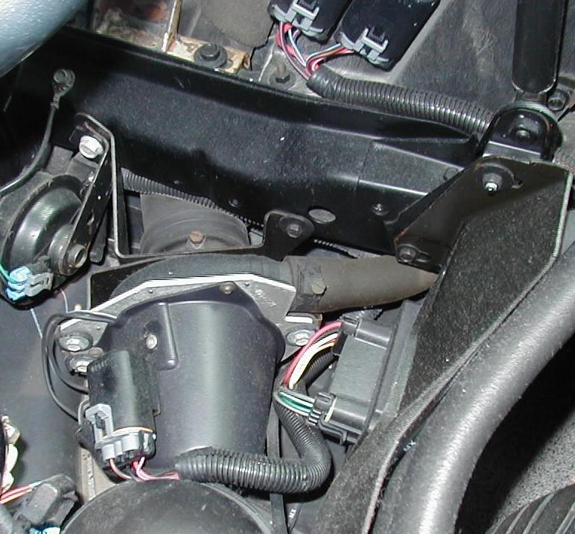 apply.

Digital multimeter (DMM)

Scan tool

Exhaust gas analyzer

Other (describe)

_______________________

_______________________

_______________________

**3.** Based on the inspection and tests, what is the needed action?

__________________________________________________________________

__________________________________________________________________