Meets ASE Task: (A8-E-5) P-3 Inspect and test electrical/electronically operated components and circuits of secondary air injection systems; determine needed action.
Name:_____________________________________
Date:_____________
Time on Task:_____________
Make/Model/Year:____________________________________
VIN:_________________________________
Evaluation (Enter number from 4, 3, 2, 1) :_________
AIR Pump Component Inspection
Page 268
1. Check service information for the recommended procedures to follow when inspecting
and testing the AIR pump components.

_________________________________________________________________

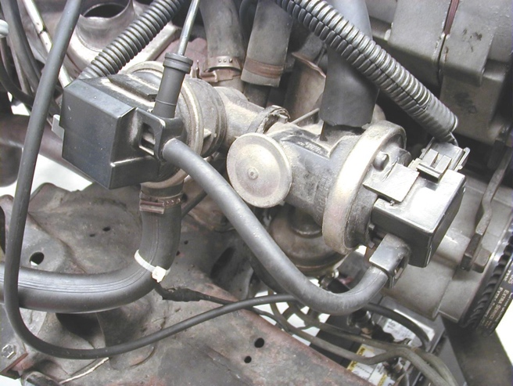
2. Carefully inspect the condition
of all the hoses, check the valves
and the metal lines for corrosion or
damage.

3. Start the engine and feel the air pump
lines to confirm the proper air flow.

NOTE: A defective one-way check valve at the exhaust manifold can allow hot exhaust gases to flow past the check valve and cause damage to the switching valves, hoses or air pump itself. These exhaust gases can cause poor engine operation and stalling if drawn into the air intake system.

4. Inspect the air pump drive belt for cracks and proper tension.

5. Based on the inspection, what is the needed action?

________________________________________________________________

________________________________________________________________

________________________________________________________________

