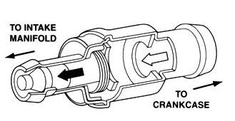
Meets ASE Task: (A8-E-3) P-2 Diagnose oil leaks, emissions, and drivability concerns caused by the positive crankcase ventilation (PCV) system; determine needed action.
Name:_____________________________________
Date:_____________
Time on Task:_____________
Make/Model/Year:____________________________________
VIN:_________________________________
Evaluation (Enter number from 4, 3, 2, 1) :_________
PCV System Diagnosis
Page 266
1. Check service information for the
recommended procedures to follow when
diagnosing the PCV system.
_____________________________

_____________________________

2. Start the engine and allow it to idle and remove the oil fill cap.

3. Place a piece of paper or a 3" x 5" card over the filler. (The PCV system is
functioning correctly if the paper is held down tight onto the filler by vacuum in the
crankcase).
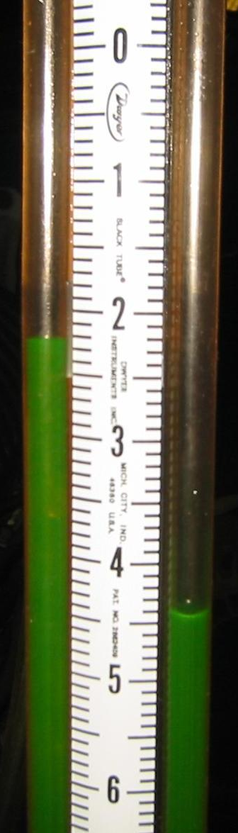
4. Seal off the oil fill opening and measure the crankcase
vacuum at the dipstick tube = ________ (should be about 0.5
in. Hg. or 7 in. or more of water if using a water manometer).

OK NOT OK

5. Based on the test results, what is the needed action?

__________________________________________

__________________________________________

__________________________________________

