Meets ASE Task: (A8-E-2) P-2 Inspect, test, service and /or replace positive crankcase ventilation (PCV) filter/breather, valve, tubes, orifices, and hoses; perform needed action.
Name:_____________________________________
Date:_____________
Time on Task:_____________
Make/Model/Year:____________________________________
VIN:_________________________________
Evaluation (Enter number from 4, 3, 2, 1) :_________
PCV System Inspection
Page 265
1. Check service information for the recommended steps to follow when testing or
servicing the positive crankcase ventilation (PCV) system.

__________________________________________________________________

__________________________________________________________________

2. Check service information and describe the location of the following:
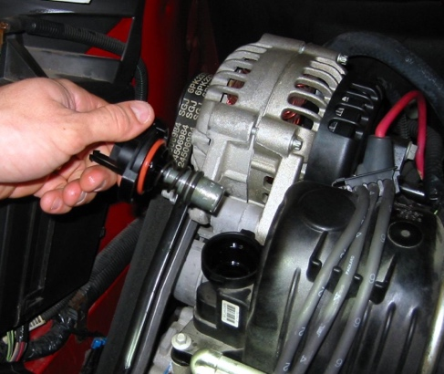
PCV valve _______________________________

Crankcase vent filter _______________________

Fixed orifice (if equipped) __________________

Other (describe) __________________________

3. What is specified replacement interval for the PCV valve?

_________________________________________________________________

4. Remove and clear the PCV valve (if equipped) and note the condition.

Like new Very dirty

Slightly dirty Valve clogged or stuck

Other (describe) _______________________________________________

5. Based on the test and inspection and on the recommendation of the vehicle
manufacturer, what is the needed action?

__________________________________________________________________

