Meets ASE Task: (A8-E-4) P-1 Diagnose emissions and drivability concerns caused by the exhaust gas recirculation (EGR) system; inspect, and test, service and/or replace electrical/electronic sensors, controls, and wiring of exhaust gas recirculation (EGR) systems tubing, exhaust passages, vacuum/pressure controls, filters, and hoses of exhaust gas recirculation (EGR) systems; determine needed action.
Name:_____________________________________
Date:_____________
Time on Task:_____________
Make/Model/Year:____________________________________
VIN:_________________________________
Evaluation (Enter number from 4, 3, 2, 1) :_________
EGR Electrical Sensors
Page 264
1. Check service information for the recommended tests and diagnostic procedure to
follow to diagnose EGR system sensors and controls.
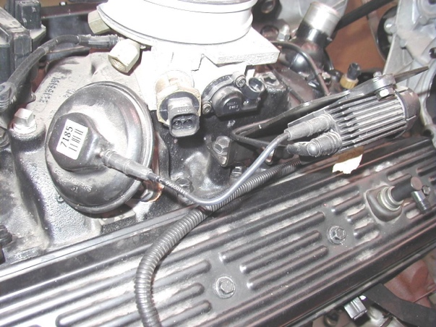
_______________________________

_______________________________

_______________________________

_______________________________

_______________________________

2. List the tools and equipment needed as specified by the vehicle manufacturer. Check
all that apply.

Scan tool

Vacuum pump

Digital multimeter (DMM)

5-gas exhaust analyzer

Other (describe) ____________________________________________

3. Based on the test results, what is the needed action?

_________________________________________________________________

_________________________________________________________________

