Meets ASE Task: (A8-E-4) P-1 Diagnose emissions and drivability concerns caused by the exhaust gas recirculation (EGR) system; inspect, and test, service and/or replace electrical/electronic sensors, controls, and wiring of exhaust gas recirculation (EGR) systems tubing, exhaust passages, vacuum/pressure controls, filters, and hoses of exhaust gas recirculation (EGR) systems; determine needed action.
Name:_____________________________________
Date:_____________
Time on Task:_____________
Make/Model/Year:____________________________________
VIN:_________________________________
Evaluation (Enter number from 4, 3, 2, 1) :_________
Service EGR System
Page 263
The EGR passages and valve that control the flow of exhaust gases can become clogged with carbon. The EGR valve and passages may need to be cleaned if one or more of the following conditions are present.

- A computer diagnosis trouble code (DTC) indicating the lack of EGR flow
- The failure of an exhaust emission test for excessive NOx
- Excessive engine spark knock (ping or detonation)

1. Check service information for the recommended procedures to follow when servicing
the EGR system.
_________________________________________________________________

2. What problem(s) exists? _________________________________________________

3. Remove the EGR valve and inspect for clogged passages. Clean as needed.

Valve was clogged Valve was OK

4. Start the engine. Exhaust should be heard and felt coming from the open passage
where the EGR valve was located.

CAUTION: Be sure to wear eye protection. Particles of carbon can be forced out of the EGR passage with great force when the engine starts.

Exhaust flowed freely Exhaust did not flow freely

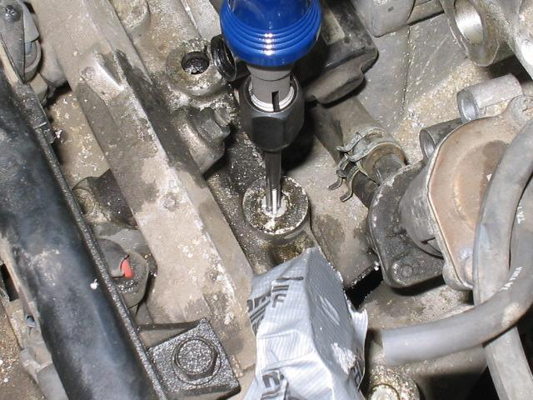
5. To clean the passages of carbon, remove the plugs or
EGR valve and insert a stiff wire into an electric drill
and use it to ream out the passages.

6. Reinstall the EGR valve with a new gasket and check
the engine for proper operation.

7. What is the needed action? ________________________
_________________________________________

