Meets ASE Task: (A8-E-4) P-1 Diagnose emissions and drivability concerns caused by the exhaust gas recirculation (EGR) system; inspect, and test, service and/or replace electrical/electronic sensors, controls, and wiring of exhaust gas recirculation (EGR) systems tubing, exhaust passages, vacuum/pressure controls, filters, and hoses of exhaust gas recirculation (EGR) systems; determine needed action.
Name:_____________________________________
Date:_____________
Time on Task:_____________
Make/Model/Year:____________________________________
VIN:_________________________________
Evaluation (Enter number from 4, 3, 2, 1) :_________
EGR System Diagnosis
Page 262
1. Check service information for the specified testing procedure of the exhaust gas
recirculation (EGR) system using a scan tool.

________________________________________________________________

________________________________________________________________

2. List the EGR-related data that can be retrieved using a scan tool.

_________________________________________________________________

3. List the scan tool commands (bi-directional) for the EGR system and describe the
results of the tests.

Unit Commanded Results
____________________________ ___________________________________
____________________________ ___________________________________
____________________________ ___________________________________

4. Has the EGR OBD II monitor run? ________________________________________
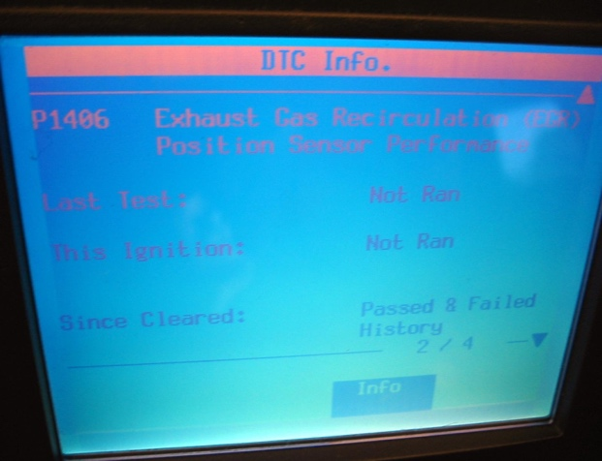
5. Based on the results of the scan tool diagnosis, what is the needed action?

________________________________
________________________________
________________________________
________________________________

