Meets ASE Task: (A8-E-8) P-1 Interpret diagnostic trouble codes (DTCs) and scan tool data related to the emissions control systems; determine needed action.
Name:_____________________________________
Date:_____________
Time on Task:_____________
Make/Model/Year:____________________________________
VIN:_________________________________
Evaluation (Enter number from 4, 3, 2, 1) :_________
Evaporative Emission DTC Diagnosis
Page 261
1. Check service information for the specified diagnostic steps to follow if evaporative emission control-related DTC(s) is set.
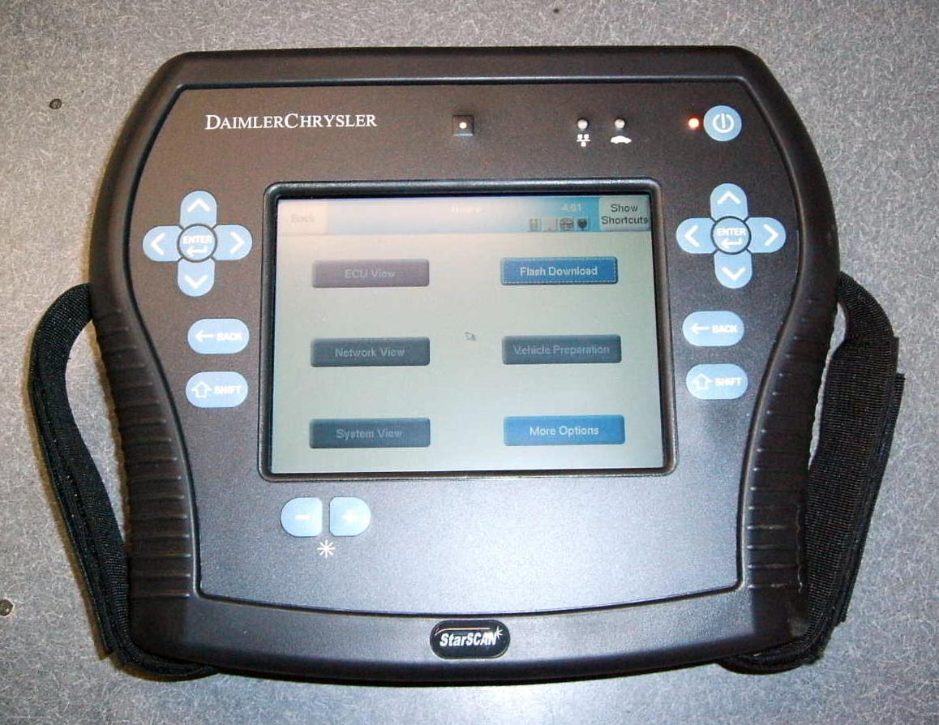

__________________________________________________________________

__________________________________________________________________

2. Describe the test and inspection specified for each of the DTCs listed.

DTC Specified Test(s)
P0440 ______________________________________________________
P0441 ______________________________________________________
P0442 ______________________________________________________
Other (list) ______________________________________________________
Other (list) ______________________________________________________

3. Based on the results of the tests and inspection, what is the needed action?

__________________________________________________________________

