Evaluation (Enter number from 4, 3, 2, 1) :_________
Meets ASE Task: (A1 through A8-A-1) P-1 Research vehicle service information such as fluid type, vehicle service history, service precautions, technical service bulletins, and recalls including vehicles equipped with advanced driver assistance systems (ADAS).

Technical Service Bulletins

Name:_____________________________________
Date:_____________
Time on Task:_____________
Make/Model/Year:____________________________________
VIN:_________________________________
Page 26
1. Technical service bulletins can be accessed through (check all that apply):
Internet site(s), specify ________________________________________
Paper bulletins, specify source __________________________________
CD ROM bulletins, specify source _______________________________
Other (describe) ______________________________________________
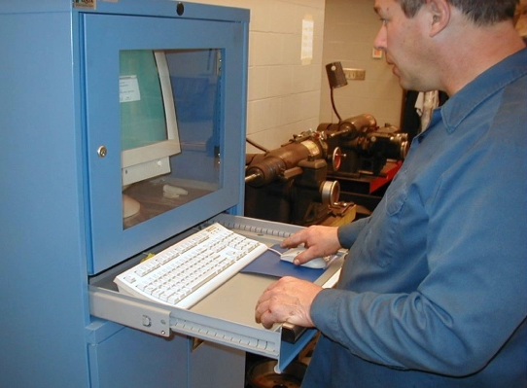

2. List all electrical-related technical service bulletins that pertain to the vehicle/engine
being serviced.
Number Description/Correction
________________ ________________________________________
________________ ________________________________________
________________ ________________________________________
________________ ________________________________________
3. Based on this research, is the information located helpful?
Yes, why? ___________________________________________________
No, why not? _________________________________________________

