Meets ASE Task: (A8-E-7) P-1 Diagnose emissions and drivability concerns caused by the evaporative emissions control (EVAP) system; determine needed action.
Name:_____________________________________
Date:_____________
Time on Task:_____________
Make/Model/Year:____________________________________
VIN:_________________________________
Evaluation (Enter number from 4, 3, 2, 1) :_________
EVAP System Component Inspection
Page 259
1. According to the underhood emission label, with what type of system is the vehicle
equipped?

Pre-OBD I (1987 or older)
OBD I (1988-1995)
OBD II (1996 and newer)
Unknown (describe) ___________________________________________
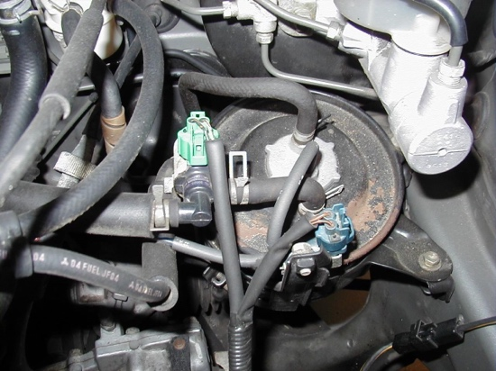
2. Check the service information and the vehicle
emission label for the following information.

a. The location of the carbon canister
(describe) ____________________
_________________________
b. The location of the purge control
solenoid(s) (describe) _____________
____________________________________________________________

c. The resistance specification for the evaporator control solenoid(s) = ________

3. Visually inspect the following items and check for any sign of a leak in the system.

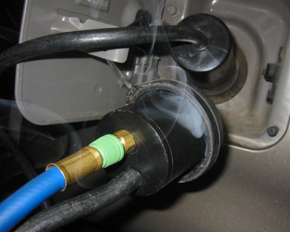
a. Canister hoses OK NOT OK
b. Gas cap OK NOT OK
4. Based on the inspection, what is the needed action?

__________________________________________

