Meets ASE Task: (A8-A-5) P-1 Identify and interpret engine performance concerns; determine needed action.
Name:_____________________________________
Date:_____________
Time on Task:_____________
Make/Model/Year:____________________________________
VIN:_________________________________
Evaluation (Enter number from 4, 3, 2, 1) :_________
Exhaust Gas Analysis
Page 258
1. Check the instruction information for the exhaust gas analyzer being used to
determine the proper test procedures to follow.

__________________________________________________________________

__________________________________________________________________

2. Check the vehicle for exhaust leaks and other faults that could affect the exhaust gas
readings.

__________________________________________________________________
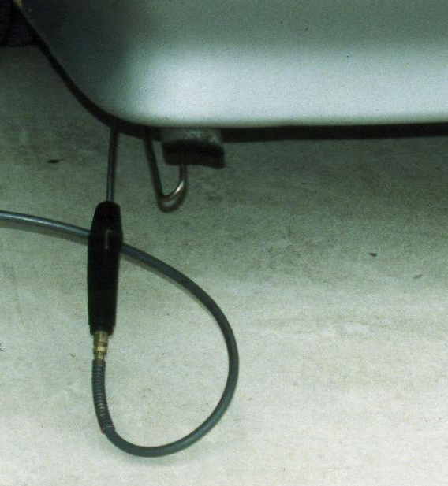
3. Prepare the vehicle for testing, which usually includes operating
the engine until normal operating temperature has been achieved.
List other items listed by the test equipment manufacturer that
should be performed.

__________________________________________

__________________________________________

4. Obtain the exhaust gas readings and compare them to specifications.

Gas | Idle | 2500 RPM | General Specifications
HC |  |  | Max 50 PPM
CO |  |  | Max 0.5%
CO₂ |  |  | 12% to 15% or higher
O₂ |  |  | 0% to 2%
NO_{X} |  |  | Less than 100 PPM @ idle  Less than 1000 PPM @ wide open throttle

_____ 5. Based on the exhaust gas readings, what is the needed action?

__________________________________________________________________

