Meets ASE Task: (A8-D-10) P-1 Inspect, test, and/or replace fuel injectors on low- and high-pressure systems.
Name:_____________________________________
Date:_____________
Time on Task:_____________
Make/Model/Year:____________________________________
VIN:_________________________________
Evaluation (Enter number from 4, 3, 2, 1) :_________
Injector Voltage Waveform Test
Page 257
1. Check service information for the type of fuel injector being used.

Saturated

Peak and hold

2. Connect a digital storage oscilloscope (DSO) or graphing multimeter (GMM) to the
pulsed side of the injector. (Check service information for the color of wire used for
the pulse.)

3. Start the engine and observe the voltage waveform.

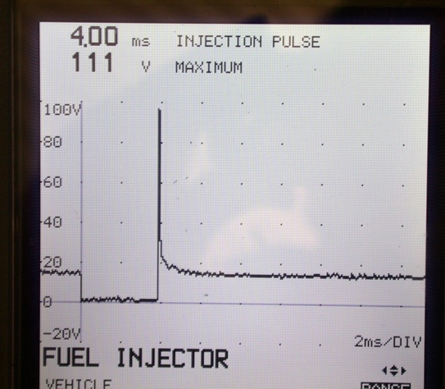

4. Does the voltage spike (kick) exceed 30 volts? Yes No

5. What is the injector pulse-width? __________ (normally between 1.5 and 3.5 mS at
idle on a warm engine)

6. Based on the test performed, what is the needed action? _______________________

_________________________________________________________________

_________________________________________________________________

