Meets ASE Task: (A8-D-10) P-1 Inspect, test, and/or replace fuel injectors on low- and high-pressure systems.
Name:_____________________________________
Date:_____________
Time on Task:_____________
Make/Model/Year:____________________________________
VIN:_________________________________
Evaluation (Enter number from 4, 3, 2, 1) :_________
Fuel Injector Balance Test
Page 256
1. Check service information for the procedures and specifications for an injector pressure balance test.

_________________________________________________________________

_________________________________________________________________
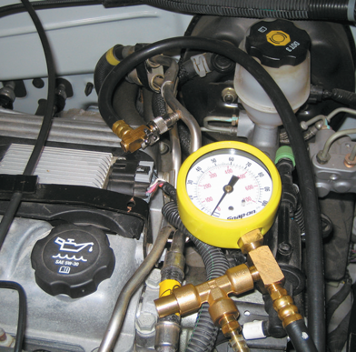
a. Part number of recommended tester = ___________

b. Maximum allowable variation in pressure drop
among the injectors = _____________

2. What was the starting pressure? _________ psi/kPa

3. Record the pressure drop of the injectors (pressure after
injector was pulsed on).

Cylinder #1 __________ Cylinder #5 __________

Cylinder #2 __________ Cylinder #6 __________

Cylinder #3 __________ Cylinder #7 __________

Cylinder #4 __________ Cylinder #8 __________

4. Compare the test results with the specifications. What is the needed action?

__________________________________________________________________

__________________________________________________________________

