Meets ASE Task: (A8-D-10) P-1 Inspect, test, and/or replace fuel injectors on low- and high-pressure systems.
Name:_____________________________________
Date:_____________
Time on Task:_____________
Make/Model/Year:____________________________________
VIN:_________________________________
Evaluation (Enter number from 4, 3, 2, 1) :_________
Injector Resistance Testing
Page 255
1. Check service information for the specified injector resistance. __________________

2. Measure the resistance of all injectors with a digital ohmmeter.
NOTE: For best performance and idle quality, all injectors should measure within
0.3 to 0.4 ohms of each other.
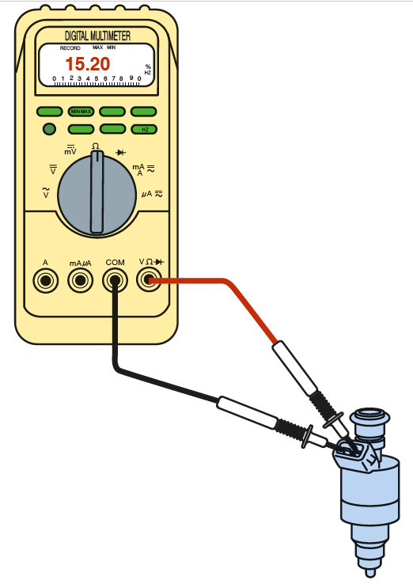
Injector resistance:
Resistance Resistance
1. __________ 5. __________
2. __________ 6. __________
3. __________ 7. __________
- __________ 8. __________

Highest resistance = ____ ohms.
Lowest resistance = ____ ohms.
Difference = ____ ohms (should be less than 0.4 ohms).
OK NOT OK

